**WEEK-2 : Logging using SLF4J**

**Exercise 1:** Logging Error Messages and Warning Levels

**Task:** Write a Java application that demonstrates logging error messages and warning levels using SLF4J.

**Code:**

**LoggingExample.java**

import org.slf4j.Logger;

import org.slf4j.LoggerFactory;

public class LoggingExample {

private static final Logger logger = LoggerFactory.getLogger(LoggingExample.class);

public static void main(String[] args) {

logger.error("This is an error message");

logger.warn("This is a warning message");

}

}

**Output:**

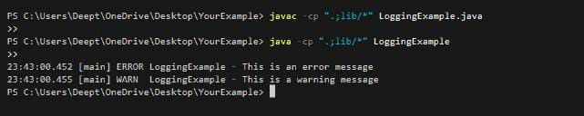

**Exercise 2:** Parameterized Logging

**Task:** Write a Java application that demonstrates parameterized logging using SLF4J**.**

**Code:**

**ParameterizedLoggingExample.java**

import org.slf4j.Logger;

import org.slf4j.LoggerFactory;

public class ParameterizedLoggingExample {

    private static final Logger logger = LoggerFactory.getLogger(ParameterizedLoggingExample.class);

    public static void main(String[] args) {

        String username = "Deepthi";

        int loginAttempts = 3;

        logger.info("User {} has logged in.", username);

        logger.warn("User {} has attempted to login {} times.", username, loginAttempts);

        logger.error("Failed login attempt for user {}", username);

    }

}

**Output:**

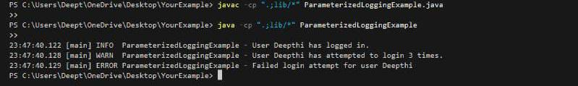

**Exercise 3:** Using Different Appenders

**Task:** Write a Java application that demonstrates using different appenders with SLF4J.

**Code:**

**AppendersExample.java**

import org.slf4j.Logger;

import org.slf4j.LoggerFactory;

public class AppendersExample {

    private static final Logger logger = LoggerFactory.getLogger(AppendersExample.class);

    public static void main(String[] args) {

        logger.info("Logging to both console and file.");

        logger.debug("This is a DEBUG message.");

        logger.warn("This is a WARN message.");

        logger.error("This is an ERROR message.");

    }

}

**Output:**

